The Ethiopian Community in Germany Held Demonstration in Nurnberg against the Killer Regime in Ethiopia
On October 27, 2012, a turnout of more than 300 Ethiopians who came from all over Germany held a demonstration which was called-up by the Ethiopian People Patriots Front in the historical city of Nurnberg against the tyrant regime in Ethiopia. The march started at 1:00 P.M. from “Plarer” through the main streets of the city then ended in the front yard of the Foreign Affairs Office Branch in Nurnberg /Auslanderamt/.

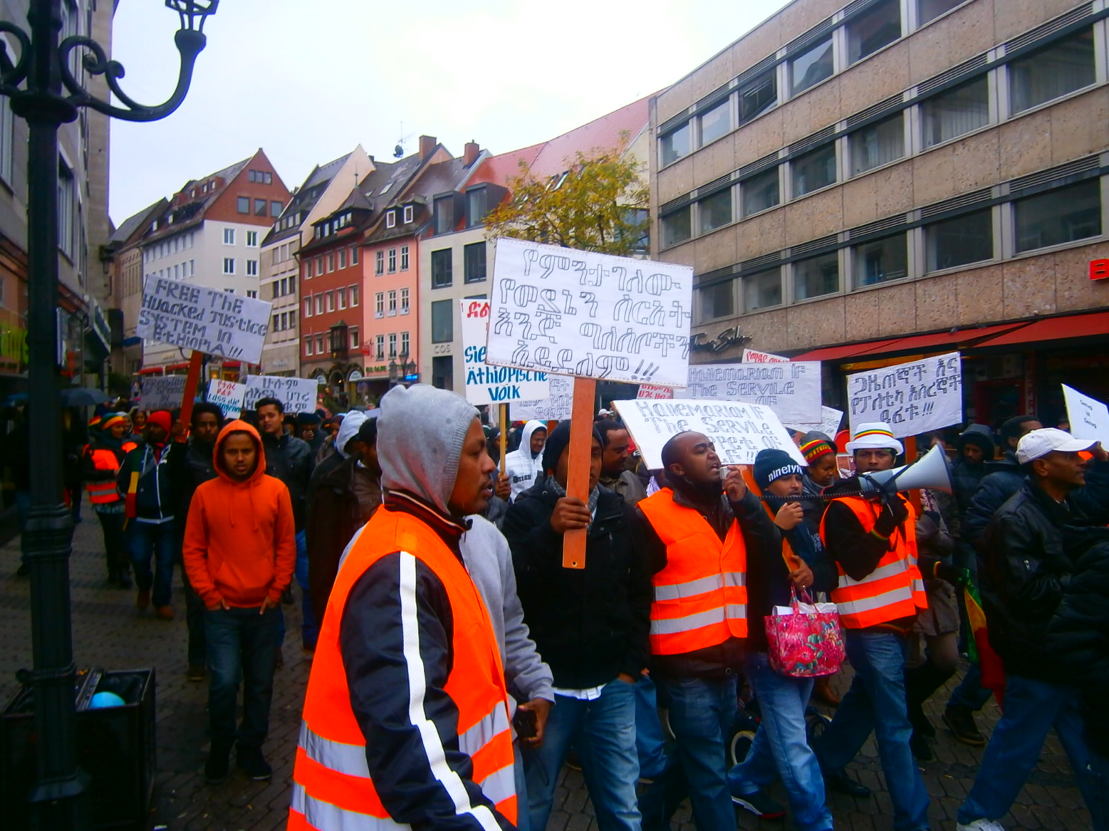

The main objective of the demonstration was:
- To denounce the murder of four innocent people who protested the interference of TPLF regime in religion-affairs in Southern Wollo by the TPLF killer men.
- To expose the tyrant regime in Ethiopia who hijacked the justice system, arrest journalists and opposition political party leaders, suppress freedom of expression and the right to exercise religion.
- To urge the European Union /EU/ in general and The Federal Republic of Germany in particular to stop and work with the dictatorial regime in Ethiopia who violates human rights and inflict massive suppression on the Ethiopian people.
The demonstration was concluded by holding a one minute Moment of Silence for those who lost their life brutally by the TPLF regime, for those who are thrown to jail unjustly; and by renewing the promises and by galvanizing the unlimited effort to forward the struggle against tyranny.

